**Name:Gaurav Kishor Patil**

**Roll No:54 Batch:C**

**Div:2**

|  |
| --- |
| Experiment No. 2 |
| Basic gates using universal gates. |
| Date of Performance:02/08/23 |
| Date of Submission:09/08/23 |

**Aim -** To realize the gates using universal gates.

**Objective -**

1. To study the realization of basic gates using universal gates.
2. Understanding how to construct any combinational logic function using NAND or NOR gates only.

**Theory -**

AND, OR, NOT are called basic gates as their logical operation cannot be simplified further.

NAND and NOR are called universal gates as using only NAND or only NOR, any logic function can be implemented.

**Components required -**

1. IC’s 7400(NAND) 7402(NOR)

2. Bread Board.

3. Connecting wires.

**Circuit Diagram -**

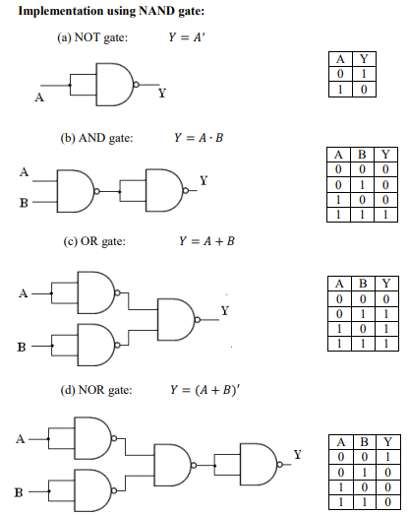

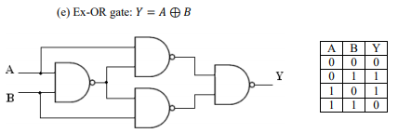

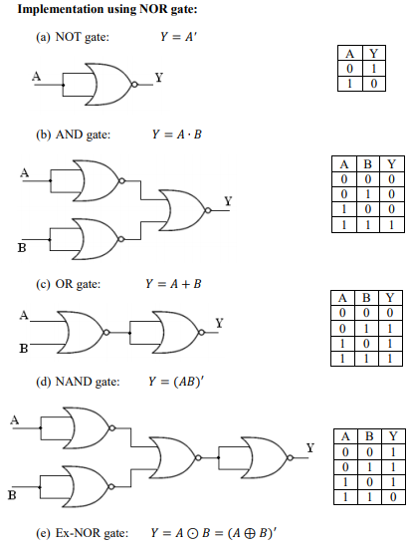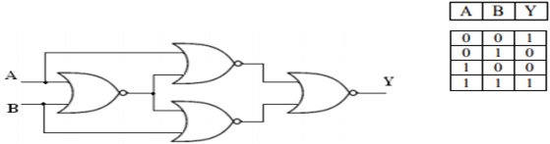

**Procedure:**

a) Connections are made as per the circuit diagrams.

b) By applying the inputs, the outputs are observed and the operations are verified with the help of truth table.

**Conclusion** -

NAND and NOR gates are called universal gates because any digital circuit can be implemented by using any one of these two i.e. any logic gate can be created using NAND or NOR gates only 1. The implementation of a logic gate using universal gates is done by replacing the basic gates with their equivalent NAND or NOR gate circuits.It is important to note that while these circuits are functionally equivalent to their basic gate counterparts, they may not be as efficient in terms of speed or area. This is because the number of gates required to implement a given function may be greater than that required for a basic gate implementation. However, the use of universal gates allows for greater flexibility in circuit design and can simplify the process of creating complex circuits.